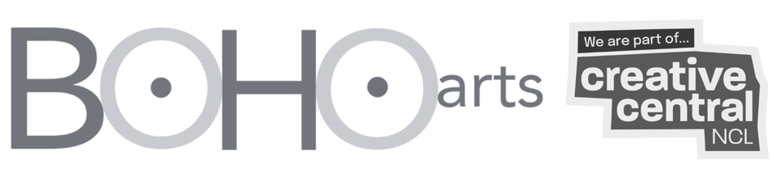
Information Memorandum
Boho Arts Limited

Boho Arts’ Inclusive Creative Arts Hub - Phase 1

Supported by
Newcastle City Council and North East Combined Authority
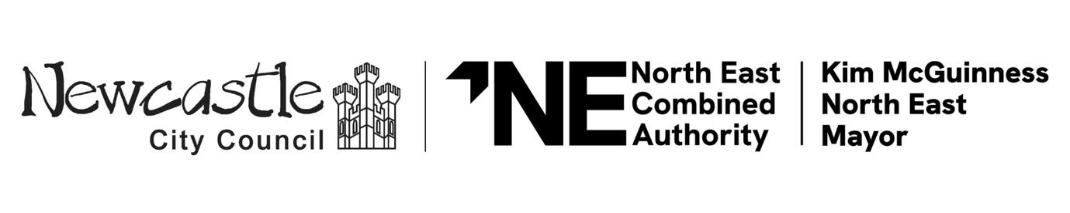
Market Engagement and Expression of Interest (EOI) Questionnaire
This document contains a soft market testing questionnaire, if your organisation is interested in participating, please complete the electronic form and return as follows: -
Completed questionnaire to be returned electronically to: | Jennifer Nuttall of Workman LLP  Jennifer.nuttall@workman.co.uk  and  Daniel Wallace of Workman LLP  daniel.wallace@workman.co.uk

This Information Memorandum has been prepared by Workman LLP on behalf of Boho Arts Limited to provide prospective bidders and other interested parties with further information about the scheme, and the procurement strategy. An Expression of Interest questionnaire is included. Organisations with relevant refurbishment experience are invited to express interest. A questionnaire is included to assist in finalising the procurement.

Disclaimer
This document does not formally signify the beginning of procurement and does not constitute a commitment to undertake any procurement exercise or to follow the process contained within.
The Employer intends to proceed to a competitive tender for the Phase 1 works following this Expression of Interest. Any appointment or contract award will be subject to the tendered sum being acceptable to the Employer and the necessary approvals. The Employer does not undertake to accept any tender.
Confidentiality Statement
The contents of this Information Memorandum and of any other documentation provided in respect of this Market Engagement are provided on the basis that they remain the property of Boho Arts and must be treated as confidential. If you are unable or unwilling to comply with this requirement you are required to destroy this Information Memorandum and all associated documents immediately and not to retain any electronic or paper copies.

By registering an interest in this Market Engagement, you agree to use this information solely for that purpose and when concluded you agree to destroy all associated documentation save for one copy which may be held physically or electronically for a period of one year after the issue of any contract award notice in respect of this procurement and shall only be used in connection with the procurement by Workman LLP.

Please be aware that the project is subject to the disclosure requirements under the Freedom of Information Act and the Environmental Information Regulations. For this reason,
it is strongly advised that any information you consider to be confidential is clearly labelled and marked as confidential.

Subject to the requirement to comply with the provisions of the Freedom Information Act / Environmental Information Regulations, any commercially sensitive information provided to us as part of this process will be treated in confidence, used only for the purposes of this Market Engagement, and will not be disclosed to any other organisation.

Boho Arts appreciate the time and effort taken to complete and submit the questionnaire. All responses will be treated as confidential and commercially sensitive. Responses will be used solely for the purpose of assessing suitability and creating a shortlist of organisations to be invited to participate in any subsequent procurement process. Information provided at this stage will not be re-used or scored as part of the evaluation of any tender submissions.

Thank you for your interest in working with us.

Introduction
Contractors with relevant refurbishment experience are invited to express interest in the redevelopment of Boho Arts’ Inclusive Creative Hub - a new arts and cultural venue located within the Creative Central NCL zone.
The project relates to the refurbishment and transformation of the existing property at 66–76 Scotswood Road, Newcastle upon Tyne, NE4 7JE, which has been vacant for several years and now requires comprehensive modernisation. The completed scheme will deliver a high-quality, purpose-built facility designed to support the long-term growth of Boho Arts and the wider creative community.
Boho Arts is a registered charity with a long-standing ambition to create accessible spaces and activities where diverse communities, artists, and audiences of all ages can come together to connect, collaborate, and be creative.
The project responds to a recognised shortage of affordable, accessible performing arts–focused spaces in central Newcastle, with many existing venues unable to meet the needs of contemporary practice or inclusive public use. The proposed development will deliver a welcoming, flexible community arts hub - a ‘Third Place’ between home and work - providing a sociable, adaptable, and inclusive environment that primarily supports performing arts activity, alongside wider creative use, artistic development, and public participation.
The new venue will provide a performing arts-led hub incorporating multi-use performance and workshop spaces supporting rehearsal, participation, and small-scale public performance, alongside complementary facilities including a café-bar and co-working office space. The completed development will support the creation and safeguarding of up to 24 jobs across artistic, operational, and hospitality roles.

Procurement
- The Expression of Interest period will run for two weeks, closing at close of business on Wednesday 11 February 2026.
- Organisations who submit an Expression of Interest will be subject to a shortlisting exercise by the client team, based on the following criteria:
- Quality and completeness of submission
- Relevant project & sector experience
- Understanding of project risks and constraints
- Approach to quality, value and collaboration
- Organisational robustness and suitability.
- Organisations shortlisted following the Expression of Interest will be invited to participate in a competitive tender process.
- The tender period is currently anticipated to commence in mid-February 2026 and to run for approximately four weeks.
- The Employer’s current intention is to procure the works via a single-stage competitive tender, based on the JCT Intermediate Building Contract with Contractor’s Design (2024 edition).
- Tenders will be evaluated against the published award criteria to determine the tender offering the best overall value for money, taking into account quality, cost and deliverability.
- Tenderers may be invited to interview to discuss their submission and relevant experience in greater detail.
- The proposed procurement approach remains subject to review following market engagement and will be confirmed prior to issue of the Invitation to Tender, having regard to market interest, deliverability and grant funding requirements.

Scope of Works
Phase 1 of the works will comprise the following principal elements:

- Whole-building repairs and future-proofing, including making safe the roof, basement, and first-floor areas to enable long-term use and subsequent phases of development.
- Full refurbishment of the ground floor to deliver key public-facing spaces, including workshop rooms, a flexible performance space with artists’ green room/dressing room, café-bar with cold kitchen, and accessible WC facilities.
- External works to provide improved amenity and servicing, including a garden area, two cycle parking zone, and refuse and recycling facilities.
- Partial refurbishment of the first floor, including the installation of a new central staircase and a platform lift between ground and first floors to provide inclusive access to office and workshop room. Remaining first-floor areas will be made safe, future-proofed, and restricted from public access as part of Phase 1.
- Sustainability and building performance measures, to be incorporated where appropriate, including energy-efficient lighting, low-energy building services, improved thermal performance, and passive ventilation strategies.
- Selective salvage and reuse of existing materials will be explored where practicable as the project progresses, with opportunities to be considered as part of the tender and construction stages where they support sustainability objectives, value for money, and programme considerations.

Phase 2
For information purposes only, the Employer is considering whether, subject to funding and approvals, a limited additional scope (Phase 2) could be delivered concurrently with Phase 1. Tenderers may be asked to comment on feasibility and costs; further information will be provided with the main tender pack.

It is not anticipated that Phase 2 will be included within the original building contract sum or programme at this stage.

Programme
The construction programme is yet to be agreed and will be a requirement of the tender submission.

Tenderers will be invited at ITT stage to propose a detailed construction programme aligned with the Employer’s requirements and constraints. The construction programme should be based on an anticipated start date of Monday 18 May 2026 (exact date may be subject to change slightly).

Appendices
- The following appendices will be shared upon request.
- Appendix 1:
- 241017-NAP-ZZ-00-DR-A-81001-P2_Existing Ground Floor
- 241017-NAP-ZZ-00-DR-A-01001-P14_Proposed Ground Floor
- 241017-NAP-ZZ-01-DR-A-81002-P2_Existing First Floor
- 241017-NAP-ZZ-01-DR-A-01002-P17_Proposed First Floor
- 241017-NAP-ZZ-B1-DR-A-81000-P2_Existing Basement Plan
- 241017-NAP-ZZ-B1-DR-A-01000-P9_Proposed Basement Plan
- 241017-NAP-ZZ-XX-DR-A-82000-P2_Existing Front & Rear Elevations
- 241017-NAP-ZZ-XX-DR-A-02000-P14_Proposed Front & Rear Elevations

Responding to the Questionnaire
Responses will be assessed for the purposes of shortlisting having regard to relevant experience, capacity to deliver, understanding of refurbishment risk, approach to quality and value, and overall suitability for the project.
- The deadline to return questionnaires is Wednesday 11 February 2026.
- All responses should be submitted on the form provided and sent via email to daniel.wallace@workman.co.uk and Jennifer.nuttall@workman.co.uk.
- Please answer all questions as indicated. Please limit your responses to no more than 250 words per question. Brochures or other general market information should not be attached.
- If you have any queries regarding the questionnaire or this exercise, please send your enquiry to daniel.wallace@workman.co.uk and Jennifer.nuttall@workman.co.uk.
- All enquiries regarding this Market Engagement exercise will be circulated via daniel.wallace@workman.co.uk. We will keep the source of any questions confidential and will circulate all questions and answers to all enquirers for information.
- The employer reserves the right to seek further clarification where this would assist in informing the process and developing appropriate and innovative service specifications.

EXPRESSION OF INTEREST QUESTIONNAIRE

Name/Position
Company Name
Street Address
Post Code
Mobile Phone
Work Phone
E-Mail Address
Trade/Specialism

Please complete this form electronically and return the form via email to the named parties at Workman LLP.
1 | Based upon this Information Memorandum, its appendices, intended procurement route and timing, form of contract and indicative start on site dates, would your organisation be interested in tendering for the contract? Please confirm your organisation’s current capacity to resource this project within the proposed programme. Please explain your answer.
1 | Click here to enter text.
2 | Considering the content of the scheme, do you consider there are more advantageous ways to structure the procurement opportunity to the mutual benefit of both parties? Please explain your answer.
2 | Click here to enter text.
3 | The scheme requires refurbishment of an existing building constructed in c. 1958 to create an inclusive arts venue. Please briefly summarise up to three relevant refurbishment projects delivered by your organisation, including project sector, value, scale, procurement route, and completion date.  Drawing on this experience, please explain how you would approach the delivery of the Boho Arts Hub project, including how your experience and resources would be applied to this scheme, the benefits of your proposed approach, and how quality and value would be considered in the delivery of a refurbishment project of this nature. (you may use up to 500 words for this question).  Click here to enter text.
4 | How would your organisation look to deliver the required works? What are the benefits of your proposed approach, particularly in relation to delivering quality outcomes within a constrained budget and managing value and cost risk?
4 | Click here to enter text.
5 | Please outline your organisation’s current workload and capacity, including the number of live projects of a similar scale and the resources you would anticipate allocating to this project should you be invited to tender.
5 | Click here to enter text.
6 | What do you consider are the main risks, issues and / or concerns with the delivery of the scheme, and how could these risks be mitigated? Please explain your answer.
6 | Click here to enter text.
7 | Please provide some narrative as what you consider sets you apart from your competitors and why you feel your company would be best placed to deliver this project.
7 | Click here to enter text.
8 | Please provide additional comments that you consider would assist in improving the current proposed offer.
8 | Click here to enter text.
9 | Please confirm that your organisation has the financial standing and turnover appropriate to undertake a project of this nature and scale, and would be able to provide relevant financial information at tender stage if required.
9 | Click here to enter text.

Next Steps

  - Following a review process with the client team, Workman LLP will shortlist four contractors to participate in the full tender process. Should you be shortlisted, you will be informed no later than close of business on Monday 16 February 2026.

Thank you for your interest.

